Presentational Markup

📌 Definition:
# Source: AI Source: Provided by: [Data Path: Persons Table -> ID Column: 1, Name_En Column: Motasem Essam] -> From: [ChatGPT] on [12/9/2025]
Presentational markup is a type of markup that focuses on how content looks (appearance) rather than its meaning or structure.

🧠 Simple idea:
# Source: AI Source: Provided by: [Data Path: Persons Table -> ID Column: 1, Name_En Column: Motasem Essam] -> From: [ChatGPT] on [12/9/2025]
Presentational = “How it looks” 👀

🔍 Key characteristics:
# Source: AI Source: Provided by: [Data Path: Persons Table -> ID Column: 1, Name_En Column: Motasem Essam] -> From: [ChatGPT] on [12/9/2025]
- 🎨 Controls visual styling directly
- 📄 Mixes content + appearance
- ❌ Less focus on meaning (semantic value)
- ❌ Considered older approach in modern web development

📌 Examples:
# Source: AI Source: Provided by: [Data Path: Persons Table -> ID Column: 1, Name_En Column: Motasem Essam] -> From: [ChatGPT] on [12/9/2025]
🏷️ HTML (older style tags)
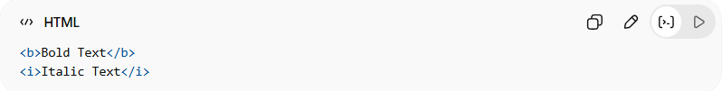
<b>Bold Text</b>
<i>Italic Text</i>
👉 These tags directly define how text looks.

📄 Legacy formatting systems
# Source: AI Source: Provided by: [Data Path: Persons Table -> ID Column: 1, Name_En Column: Motasem Essam] -> From: [ChatGPT] on [12/9/2025]
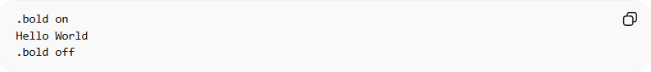
.bold on
Hello World
.bold off
👉 Commands directly control appearance.

⚙️ Real-world note:
# Source: AI Source: Provided by: [Data Path: Persons Table -> ID Column: 1, Name_En Column: Motasem Essam] -> From: [ChatGPT] on [12/9/2025]
Modern web development avoids presentational markup and instead uses:
- 🏷️ HTML → structure
- 🎨 CSS → styling

🆚 Presentational vs Semantic
# Source: AI Source: Provided by: [Data Path: Persons Table -> ID Column: 1, Name_En Column: Motasem Essam] -> From: [ChatGPT] on [12/9/2025]
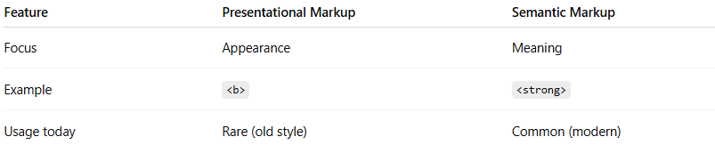
Feature | Presentational Markup | Semantic Markup
Focus | Appearance | Meaning
Example | <b> | <strong>
Usage today | Rare (old style) | Common (modern)

🎯 Summary:
# Source: AI Source: Provided by: [Data Path: Persons Table -> ID Column: 1, Name_En Column: Motasem Essam] -> From: [ChatGPT] on [12/9/2025]
Presentational markup directly controls how content looks, but modern practices prefer separating style using CSS.

